**Exercises: CRUD Operations**

This document defines **exercise assignments** for the ["Databases Advanced – EF Core" course @ Software University](https://softuni.bg/trainings/3221/entity-framework-core-february-2021).

## Create the Database

Create a MongoDB database with the name "Articles" and populate it using the following JSON**:**

|  |
| --- |
| Sample code usage |
| {  "articles": [  {  "author": "Bill Gates",  "date": "27-01-2020",  "name": "Top 5 programming languages in 2020",  "rating": "5"  },  {  "author": "Svetlin Nakov",  "date": "02-05-2020",  "name": "How to write bug-free code",  "rating": "10"  },  {  "author": "Nikolay Kostov",  "date": "08-07-2020",  "name": "Set up your very own web server!",  "rating": "20"  },  {  "author": "Elon Musk",  "date": "17-04-2020",  "name": "The future of space travel",  "rating": "50"  },  {  "author": "Alen Paunov",  "date": "10-07-2020",  "name": "How to manage effectively",  "rating": "50"  }  ]  } |

Create a **Console Application** (.Net Core) and **connect it to your MongoDB database**. To do that, first **install the NuGet package MongoDB.Driver.**

## Read

Print on the console the names of all articles in the database.

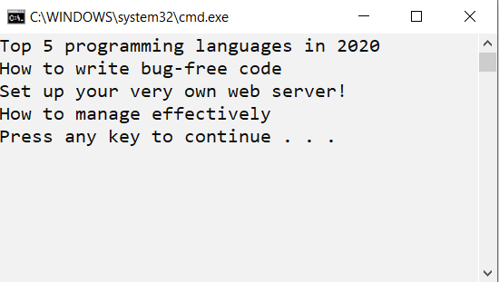

## Create a new article

Add a new article with author "Steve Jobs", date "05-05-2005", name "The story of Apple", rating "60".

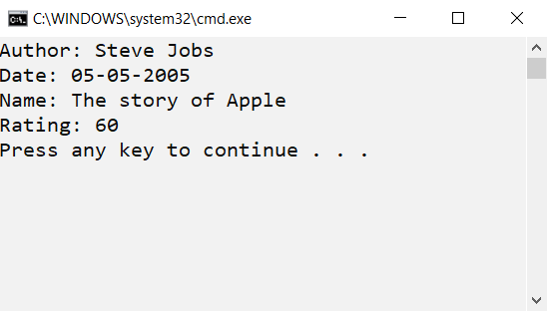

## Update

Add 10 points to the rating of all articles.

## Delete

Delete all articles with rating **less than or equal to 50**. Print the names of the remaining articles on the Console.

